# Cortex-M4 Experiments with S800 Board

## Experiment Two: I2C and SysTick Interrupts

* **General Description and Goals:**

In this experiment, you should be familiar with: 1) I2C protocol; 2) PCA9557 and TCA6424 I2C I/O expender chips; 3) LEDs and digitron display; 4) interrupt driven programming.

* **Experiment Requirements:**

1. Read the example code and understand the initialization of PCA9557 and TCA6424C chips. In this example code, PCA9557 is used control LEDs and TCA6424 is used to control the 8-digit digitron.
2. Program to control LEDs and digitron to display in a moving fashion. In specific, when LED1 is turned on, the first digit of the digitron displays “1”. Then, LED1 and the first digit are put off and the second LED LED2 is turned on and the second digit of the digitron displays “2”. The process continues until the LED8 is turn on and the eighth digit of the digitron displays “8”. After that, the whole process repeats.
3. In addition to Requirement 2, when USR_SW1 is pressed, the movement of the LEDs and the digitron stops and when USR_SW1 is released, the process continues.
4. Use interrupt-driven programming on SysTick to achieve Requirement 2 and 3, respectively.

5.* Use SysTick to simulate a multi-task system where Task1: PF0 flashes; Task 2: moving display of LEDs and the digitron; Task 3: press and hold USR_SW1 to keep PN0 on, and put off PN0 when USR_SW1 is released. When Task 3 is running, Task 1 and Task 2 are suspended; otherwise, Task 1 and Task 2 run alternately.

* **Related On-Board Components:**

On the LaunchPad:

|  |  |  |
| --- | --- | --- |
| Label | Connected MCU Pin | Description |
| RESET | RESET | TM4C1294NCPDT Reset Button: low effective |
| WAKE | WAKE | Wake event for bring the MCU back from hibernation mode |
| USR_SW1 | PJ0 | User button: low effective |
| USR_SW2 | PJ1 | User button: low effective |
| D0 |  | 3.3V power indicator, green LED, high effective |
| D1 | PN1 | User green LED, high effective |
| D2 | PN0 | User green LED, high effective |
| D3 | PF4 | User green LED, high effective |
| D4 | PF0 | User green LED, high effective |

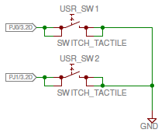

*Note that PJ0 and PJ1 connected to USR_SW1 and USR_SW2, respectively, should be programmed with weak pull-up configuration in order to get stable button status.*

On the blue board:

|  |  |  |
| --- | --- | --- |
| Label | Connected MCU Pin | Description |
| LED_M0 | PF0 | User green LED, low effective |
| LED_M1 | PF1 | User green LED, low effective |
| LED_M2 | PF2 | User green LED, low effective |
| LED_M3 | PF3 | User green LED, low effective |
| D10 |  | 3.3V power indicator, red LED, high effective |

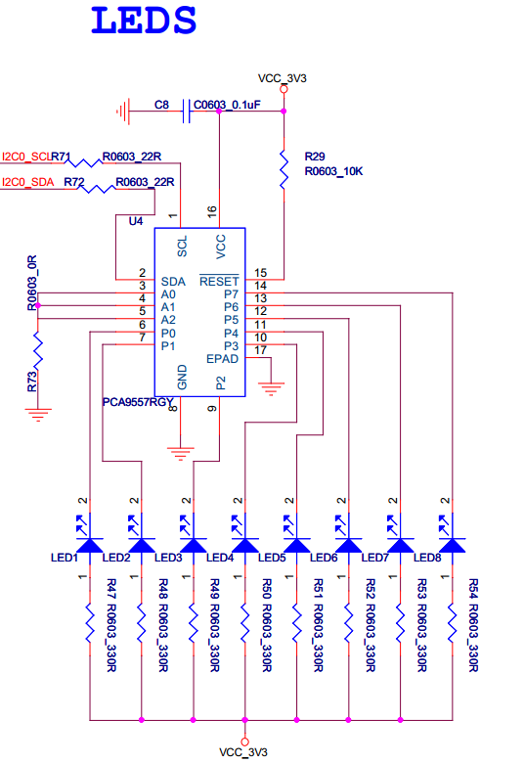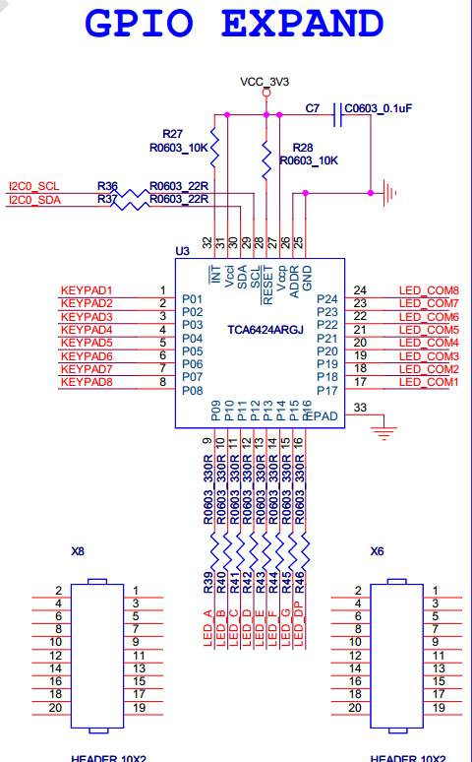

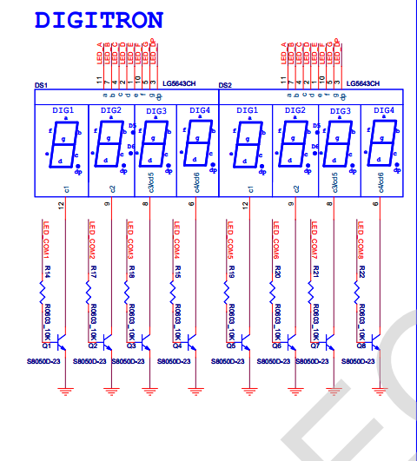

* **Related Peripheral Driver Library Functions:**

**System Clock:**

1. To configure the system clock: SysCtlClockFreqSet();
2. **For TM4C129 devices**, the return value from SysCtlClockFreqSet() indicates the system clock frequency.

**GPIO:**

1. To program on a GPIO port, first you need to supply system clock to that GPIO block using SysCtlPeripheralEnable();
2. You can check whether a peripheral is ready after clocking: SysCtlPeripheralReady();
3. To configures pin(s) for use as GPIO inputs, use GPIOPinTypeGPIOInput()and for use as GPIO outputs, use GPIOPinTypeGPIOOutput(); Sets the pad configuration for the specified pin(s), use GPIOPadConfigSet(); read a value from or write a value to the specified pin(s) use GPIOPinRead() and GPIOPinWrite(), respectively;
4. To configure the alternate function of a GPIO pin, use: GPIOPinConfigure() and to fully configure a pin, a GPIOPinType*() function should also be called.

**SysTick:**

1. To setup the initial count of SysTick: SysTickPeriodSet();
2. To enable SysTick: SysTickEnable();
3. **For software pulling**, you can read the current count of SysTick: SysTickValueGet();
4. **For interrupt-driven programming**, first you need to enable SysTick exceptions: SysTickIntEnable(); then enable the processor interrupt: IntMasterEnable(); last, implement the SysTick handler.

**I2C:**

1. To program on a I2C module, first you need to supply system clock to that I2C module using SysCtlPeripheralEnable();
2. If pins used by the I2C module is used as GPIO by default, then you need to configure these pins to the proper function;
3. Enable the I2C Master function of the I2C module using I2CMasterEnable();
4. Set the desired SCL clock speed using I2CMasterInitExpClk();
5. Specify the slave address of the master:I2CMasterSlaveAddrSet();
6. **For master writing**, place data (byte) to be transmitted in the data register: I2CMasterDataPut();start to transfer data using I2CMasterControl(); you can check whether the data transfer is completed using I2CMasterBusy();repeat this process until all data is transferred (putting an end condition when calling I2CMasterControl());
7. **For master reading**, start to receive data using I2CMasterControl(); you can check whether the data transfer is completed using I2CMasterBusBusy();get the value from the return of I2CMasterDataGet();

* **Questions:**

1. When PLL is used, what is the lowest (highest) frequency of the system clock?

30 kHz

1. In Requirement 2, only one LED is moving. Program to make two LEDs move. For example, when displaying “1”, LED8 and LED1 are turned on; when displaying “2”, LED1 and LED2 are turned on; so on and so forth.
2. In addition to Question 2, program to make two digits move at the same time. For instance, when displaying “1” and “2”, LED1 and LED2 are turned on; when displaying “2” and “3”, LED 2 and LED3 are turned on; …; when displaying “8” and “1”, LED8 and LED1 are turned on.
3. Use USR_SW1 to control the frequency of the moving display. In specific, when USR_SW1 is pressed for the first time, the time duration between digits is 1s; when USR_SW1 is pressed for the second time, the duration is 2s; when USR_SW1 is pressed for the third time, the duration is 0.2s; when USR_SW1 is pressed for the fourth time, the duration is 0.5s; the process repeats.
4. Implement a digital clock on the digitron. Specifically, time MM:SS is displayed on the first five digits. MM is the 2-digit minute and SS is the 2-digit second. SS increases on every second and MM increases every time when 60 seconds are reached. When USR_SW1 is pressed, SS increases by 1; when USR_SW2 is pressed, MM increases by 1; when either key (both keys) is (are) pressed and held, the corresponding SS or (and) MM keeps (keep) increasing at an interval of 200ms.